Linux for Data Engineers – Group Practical Activity Brief 2

**Searching for Files and Directories**

1. **Using ‘find’ to search for Files and Directories**

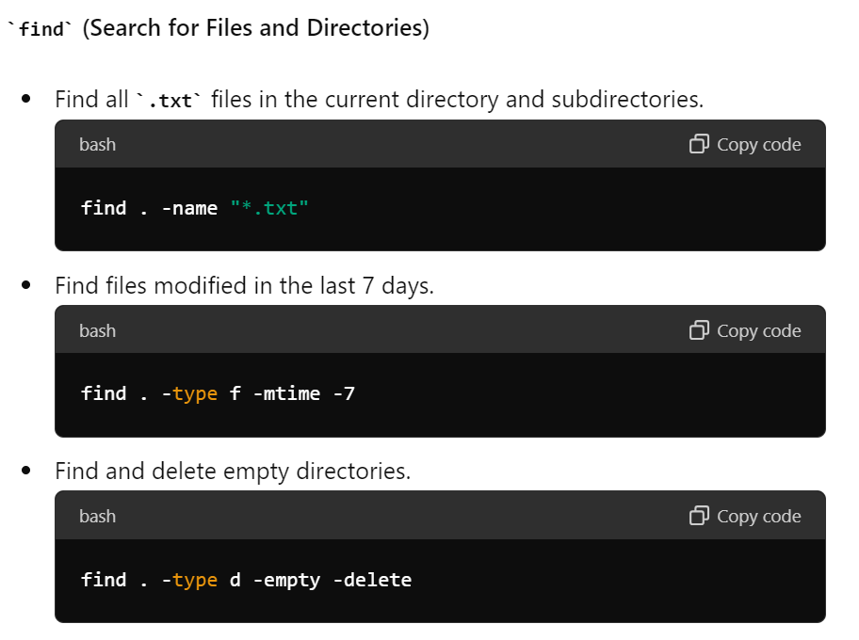

1. **Using ‘grep’ to search inside files**

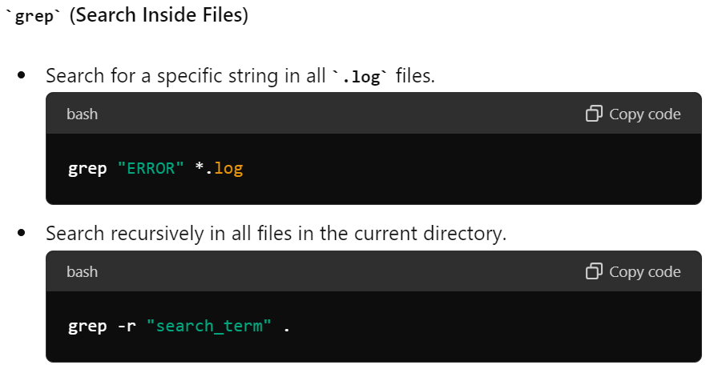

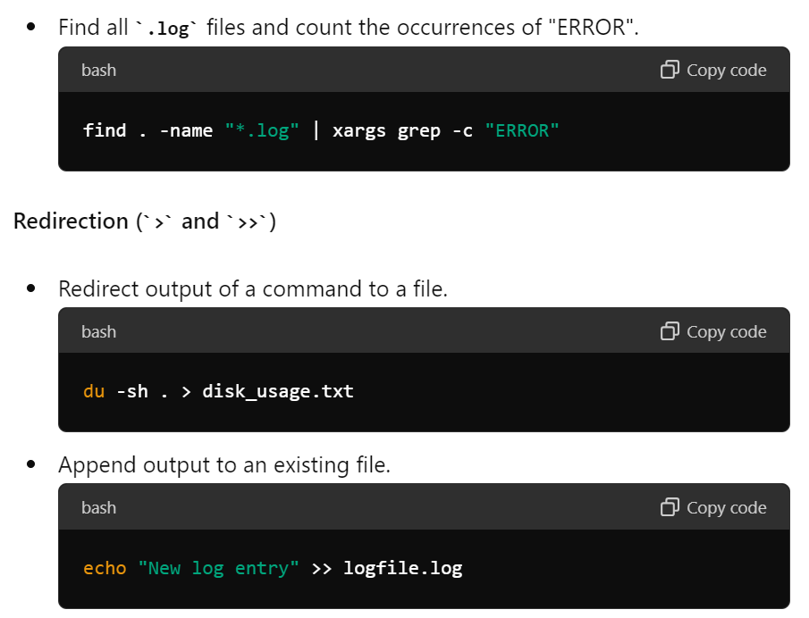

1. **Changing file permissions**

1. **Using ‘at’ for one-time tasks**

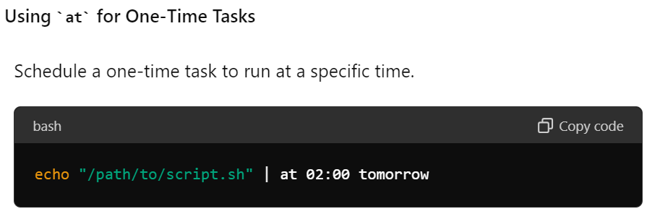

1. **Using ‘cron’ for regularly scheduled tasks**

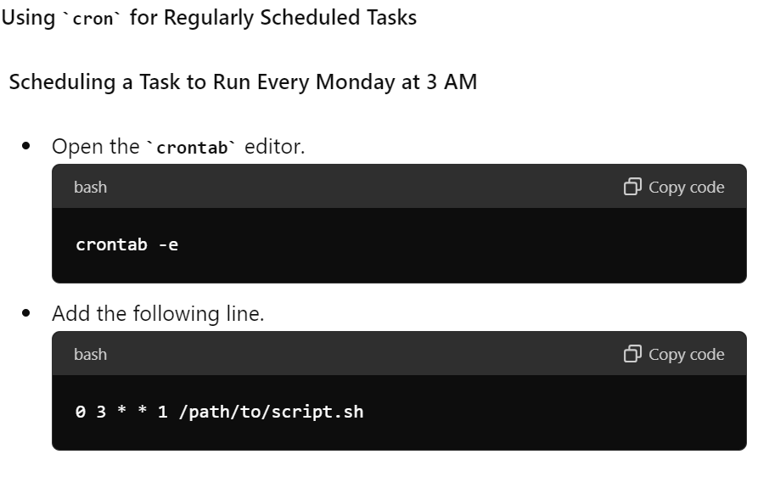

More about Cron [here](https://en.wikipedia.org/wiki/Cron).